**BERGRIVIER MUNICIPALITY**

**COVID-19: ECONOMIC RECOVERY PLAN**

**AUGUST 2020**

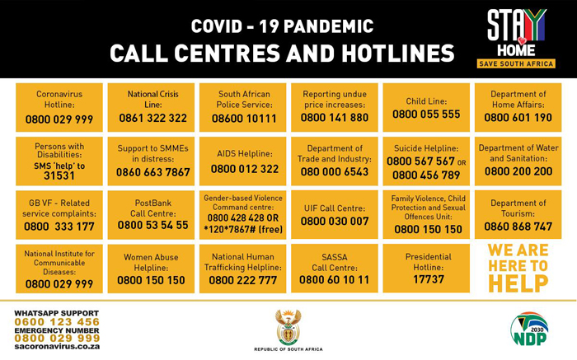

Table of Contents

1. PURPOSE OF ECONOMIC RECOVERY PLAN 3

2. METHODOLOGY 3

3. SITUATIONAL ANALYSIS: IMPACT OF COVID-19 ON THE ECONOMY 3

3.1 Western Cape Government: Model developed to measure impact of Covid-19 3

3.2 West Coast District: Impact of Covid-19 on the economy of the West Coast 6

3.3 Bergrivier Municipality: Impact of covid-19 on the economy of Bergrivier Municipality 7

3.4 The Joint District Approach in and for the West Coast 10

4. POTENTIAL SHORT-, MEDIUM AND LONG TERM INTERVENTIONS IN THE ECONOMIC RECOVERY FOR BERGRIVIER MUNICIPALITY 12

4.1 Points of Departure 12

4.2 Practical implementation plans for Bergrivier Municipal Area 13

4.2.1 Impact per sector 13

4.2.2 Implementation Plan 15

4.3 Current funding options for businesses 20

# PURPOSE OF ECONOMIC RECOVERY PLAN

South Africa currently is in a fiscally constrained environment with a domestic market in recession. With lockdown since March 2020, it means continuous business closures, more job losses, decreasing demand for products and services leading to even more business closures and job losses. In the light of this context, an Economic Recovery plan for Bergrivier Municipality is required with short-, medium- en long term plans to facilitate a potential turnaround of the current distressing circumstances of and for the business sector.

# METHODOLOGY

In drafting the Bergrivier Municipality Economic Recovery Plan, the following methodology was used:

1. The Western Cape Economic Recovery Model was used as the baseline information to inform the strategy for Bergrivier Municipality;
2. A virtual meeting was held on Friday, 24 July 2020, with the stakeholders in the tourism industry in Bergrivier Municipal Area and included the manager and the various tourism officials in Bergrivier Municipal Area. A follow-up meeting will took on 29 July 2020.
3. A survey with questions on the impact of Covid-19 on businesses in Bergrivier Municipal Areas was distributed amongst businesses. The questionnaire is attached. (Due to the low response rate, no significant analysis could be made from the surveys received).
4. Stakeholders that have been consulted included Western Cape Department of Economic Development and Tourism, Wesgro, SMME Forums in Bergrivier Municipal Area, local tourism offices and the Saldanha IDZ.
5. Weekly virtual meetings with district LED Managers and provincial stakeholders were attended and inputs from these meetings were included in the draft Bergrivier Economic Recovery Plan;
6. The draft Bergrivier Economic Recovery Plan is first submitted to the Economic Portfolio Committee on 5 August 2020 to workshop the draft plan;
7. The final draft will be submitted to the Executive Mayoral Committee for approval via inputs from the Directors’s meeting.

# 3. SITUATIONAL ANALYSIS: IMPACT OF COVID-19 ON THE ECONOMY

## 3.1 Western Cape Government: Model developed to measure impact of Covid-19

The Department of Economic Development and Tourism developed a model to measure the impact of Covid-19 on the economies of the various municipal areas in the Western Cape. Various engagements took place with a number of stakeholders from various industries. The sector descriptive baseline included sectoral GVA (Gross Value Added – measure of the value of goods and services produced in an area, industry or sector of an economy), employment, labour remuneration per sector, supply chains, trade exposure and domestic macro exposure. It needs to be mentioned that the draft provincial plan is not finalised yet and may only be available in November 2020. It remains however, important to align municipal economic recovery plans with the provincial recovery and district recovery plan, even if it is only on a framework level.

Three scenarios have been developed per sector, namely mild, medium and severe impact. The assumptions for the three scenarios can be portrayed as follows:

|  |  |  |  |
| --- | --- | --- | --- |
|  | **SCENARIOS** | | |
| **MILD** | **MEDIUM** | **SEVERE** |
| Shutdown Length | 5 weeks, rapid opening up | 5 weeks, gradual opening up | 5 weeks and with a return to level 4 |
| Level of Lockdown | Level 0 - Jan to March  Level 5 – April  Level 4 – May  Level 3 – June  Level 2 – July  Level 1 - Aug to Dec | Level 0 - Jan to March  Level 5 – April  Level 4 – May  Level 3 – June  Level 2 – Aug  Level 1 - Nov | Level 0 - Jan to March  Level 5 – April  Level 4 – May  Level 3 – June  Level 4 - Sept to Oct (second wave) |
| Severity of infection rate | Peaking in end of July/Aug, one wave | Peaking in end of July/Aug, one wave | Peaking in end of July/Aug, second wave of infection Sept/Oct |
| Bounce Back | Rapid Recovery | Medium Recovery | Slow Recovery |
| Shape of Recovery | V -shape curve | U - shape curve | L - shape curve |

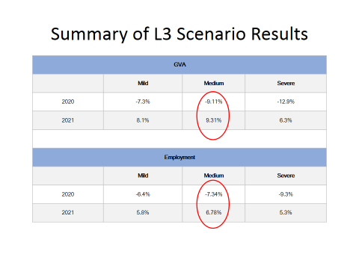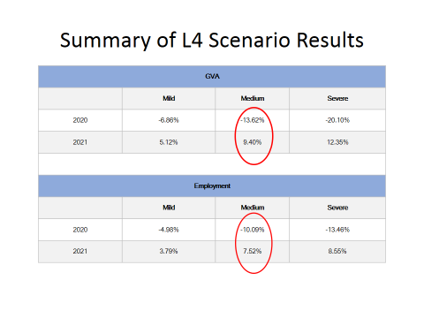Significant research was conducted on the impact of the lockdown since March 2020 during the various levels of lockdown. For the purposes of this plan, only a brief summary of the impact during Level 4 and Level 3 for the Western Cape is provided and can be portrayed as follows:

For more detail on the impact of the lockdown during Level 3 per sector, the following tables measured firstly direct and indirect job losses per sector for the whole of the Western Cape and secondly a breakdown as measured by GVA impact per sector:

|  |  |  |  |  |  |  |
| --- | --- | --- | --- | --- | --- | --- |
|  | Total GVA in 2019 | Net GVA loss | Net loss as a % of sub sector | Total employed in 2019 | Net Employment Losses | Net employment loss % of subsector |
|
|
|
| Tourism | 15 534 736 | 9 283 443 | 59,76% | 174 982 | 74 646 | 42,66% |
| Agriculture | 21 094 310 | 1 335 973 | 6,33% | 209 798 | 10 763 | 5,13% |
| Mining | 1 743 156 | 154 562 | 8,87% | 4 590 | 75 | 1,64% |
| Manufacturing | 94 959 965 | 6 540 570 | 6,89% | 295 183 | 6 565 | 2,22% |
| Electricity | 17 704 233 | 614 148 | 3,47% | 8 892 | 92 | 1,03% |
| Construction | 31 715 441 | 4 499 025 | 14,19% | 159 542 | 17 450 | 9,25% |
| Trade | 102 087 570 | 9 029 504 | 8,84% | 354 328 | 21 794 | 6,15% |
| Transport (incl telecoms) | 59 716 800 | 7 845 122 | 13,14% | 54 100 | 2 028 | 3,75% |
| Finance (finance, insurance, real estate and other services | 156 953 508 | 7 384 327 | 4,70% | 466 741 | 2 670 | 0,57% |
| Community Services (Public admin, defence, health,social work, other community services | 111 637 537 | 9 197 565 | 8,24% | 354 331 | 9 114 | 2,57% |
| Informal | - | - | - | 301 543 | 32 522 | 10,79% |
| Total | 613 147 256 | 55 884 239 |  | 2 384 029 | 175 019 |  |
|  |  | 9,11% |  |  | 7,34% | -7,34% |

The study of DEDAT can also be summarised by the following statements contextualising the economic status in South Africa:

1. GDP growth in SA and Western Cape has been in decline over the years;
2. SA is an extremely poor performer particularly when compared to the middle income countries;
3. GDP per capita in SA and Western Cape has been declining over the years and SA is an extremely poor performer when compared to BRICS;
4. The unemployment rate has increased over years;
5. There has been an increase of 551 278 poor people in the Western Cape between 2001 – 2017;
6. The Gini Coefficient has worsened from 0.607 to 0.613 in the Western Cape between 2013 – 2017;
7. South Africa experiences human capital challenges with

* a much lower productivity percentage growth than other countries;
* SA’s overall unit labor cost in dollar terms more volatile than other countries;
* SA’s demand for skilled labour is increasing 2x faster than unskilled;
* SA work stoppages far higher than other countries;
* Lack of skilled labour appears to be a problem as much as surplus of unskilled labour;

1. SA’s cost of capital higher than most peer countries
2. Limited utilisation of technology and innovation to improve competitiveness appears to be a binding constraint;
3. Shrinking manufacturing production;
4. Reliability of energy is a challenge;
5. Water scarcity
6. Low business confidence results in businesses not making investments into the economy.

## 3.2 West Coast District: Impact of Covid-19 on the economy of the West Coast

For the West Coast, based upon the above model, the impact on the economy in terms of GVA and employment on the economy of the West Coast can be summarised as follows:

|  |  |  |
| --- | --- | --- |
|  | YEAR 1 POST C-19 | YEAR 2 POST C-19 |
| GVA | -13.4% | 9.6% |
| Employment | -7.0% | 5.3% |

The following tables provides an overview of the impact of the lockdown on the GVA of the West Coast District Municipal Area as well as in terms of job losses:

|  | **TOTAL GVA IN 2019** | **POST 1-2 MONTHS GVA LOSS** | **POST 3-6 MONTHS GVA LOSS** | **POST 7-12 MONTHS GVA LOSS** | **NET GVA LOSS** | **NET LOSS AS A % OF SUB SECTOR** | **NET LOSS AS A % OF TOTAL GVA** | **POST 13 - 24 MONTHS GVA LOSS** | **NET LOSS AS A % OF GVA** |
| --- | --- | --- | --- | --- | --- | --- | --- | --- | --- |
| Tourism | 549,209 | 66,409 | 175,747 | 219,684 | 461,839 | 84.1% | 1.5% | 274,605 | 50.0% |
| Agriculture | 4,205,054 | 141,607 | 140,168 | 50,180 | 331,955 | 7.9% | 1.1% | 53,926 | 1.3% |
| Mining | 245,137 | 24,245 | 20,428 | 4,675 | 49,348 | 20.1% | 0.2% | 14,679 | 6.0% |
| Manufacturing | 5,498,279 | 221,556 | 311,555 | 149,124 | 682,235 | 12.4% | 2.3% | 320,835 | 5.8% |
| Electricity | 1,118,584 | 14,104 | 22,171 | 11,186 | 47,461 | 4.2% | 0.2% | 55,929 | 5.0% |
| Construction | 1,511,619 | 113,371 | 200,895 | 301,097 | 615,364 | 40.7% | 2.1% | 151,162 | 10.0% |
| Trade | 4,645,695 | 221,642 | 201,679 | 193,067 | 616,387 | 13.3% | 2.1% | 273,540 | 5.9% |
| Transport (incl telecomms) | 3,213,717 | 266,642 | 143,747 | 217,574 | 627,963 | 19.5% | 2.1% | 148,749 | 4.6% |
| Finance (finance, insurance, real estate and other services) | 4,360,753 | 78,359 | 72,679 | 87,495 | 238,533 | 5.5% | 0.8% | 180,633 | 4.1% |
| Community services (Public admin, defence, health & social work, other community services) | 4,473,969 | 64,202 | 125,077 | 135,539 | 324,818 | 7.3% | 1.1% | 31,945 | 0.7% |
|  | 29,822,016 | 1,212,135 | 1,414,148 | 1,369,621 | 3,995,904 |  |  | 1,506,003 |  |
|  |  | 4.06% | 4.74% | 4.59% | 13.40% |  |  | 5.05% |  |

|  | **TOTAL EMPLOYED IN 2019** | **POST 1-2 MONTHS EMPLOY-MENT LOSS** | **POST 3-6 MONTHS EMPLOY-MENT LOSS** | **POST 7-12 MONTHS EMPLOY-MENT** | **NET EMPLOY-MENT LOSSES** | **NET EMPLOY MENT LOSS % OF SUB SECTOR** | **NET LOSS AS A % OF TOTAL EMPLOY-MENT** | **POST 13 - 24 MONTHS EMPLOY-MENT LOSS** | **NET LOSS AS A % OF EMPLOY-MENT** |
| --- | --- | --- | --- | --- | --- | --- | --- | --- | --- |
| Informal | 13,694 | 703 | 767 | 268 | 1,738 | 12.7% | 1.1% | 110 | 0.8% |
| Tourism | 7,092 | 579 | 1,634 | 2,043 | 4,256 | 60.0% | 2.7% | 1,702 | 24.0% |
| Agriculture | 63,047 | 118 | 525 | 144 | 787 | 1.2% | 0.5% | 7 | 0.0% |
| Mining | 634 | 4 | 18 | 5 | 28 | 4.4% | 0.0% | 13 | 2.1% |
| Manufacturing | 19,373 | 111 | 387 | 222 | 720 | 3.7% | 0.5% | 406 | 2.1% |
| Electricity | 362 | 0 | 2 | 2 | 4 | 1.1% | 0.0% | 6 | 1.8% |
| Construction | 7,165 | 408 | 533 | 913 | 1,855 | 25.9% | 1.2% | 344 | 4.8% |
| Trade | 14,904 | 111 | 278 | 391 | 780 | 5.2% | 0.5% | 403 | 2.7% |
| Transport (incl telecomms) | 2,536 | 16 | 44 | 75 | 135 | 5.3% | 0.1% | 40 | 1.6% |
| Finance (finance, insu-rance, real estate and other services) | 14,406 | 66 | 96 | 171 | 333 | 2.3% | 0.2% | 272 | 1.9% |
| Community services (Public admin, defense, health & social work, other community services) | 16,113 | 22 | 210 | 266 | 498 | 3.1% | 0.3% | 53 | 0.3% |
| Total | 159,326 | 2,141 | 4,496 | 4,499 | 11,135 |  |  | 3,355 |  |
|  |  | **1.34%** | **2.82%** | **2.82%** | **6.99%** | **-7.0%** |  | **2.11%** |  |

## 3.3 Bergrivier Municipality: Impact of Covid-19 on the economy of Bergrivier Municipality

The tertiary sector contributed the most to GDPR in the Bergrivier Municipal Area with a combined value of R 1.9 billion in 2017. However, the 2 individual sectors which drive the economy are the agriculture, forestry and fishing sector, which contributed R 1.3 billion in 2017, and the manufacturing sector, which contributed R 1.0 billion in the same year. The agriculture, forestry and fishing sector realised strong growth rates over a 10 year period of 4.4 % /annum. This made the primary sector the main driver of growth in the municipal area. Other sectors which experience strong growth rates (2008 – 2017) included finance, insurance, real estate and business service sector (3.7 %) and the construction sector (3.6 %). The main source of job creation (2008 – 2017) was the tertiary sector which registered a net increase of 2 410 jobs. This was largely in the wholesale and retail trade, catering and accommodation sector. A negative job loss was however registered for the whole of the municipal area due to the shedding of jobs in the primary sector.

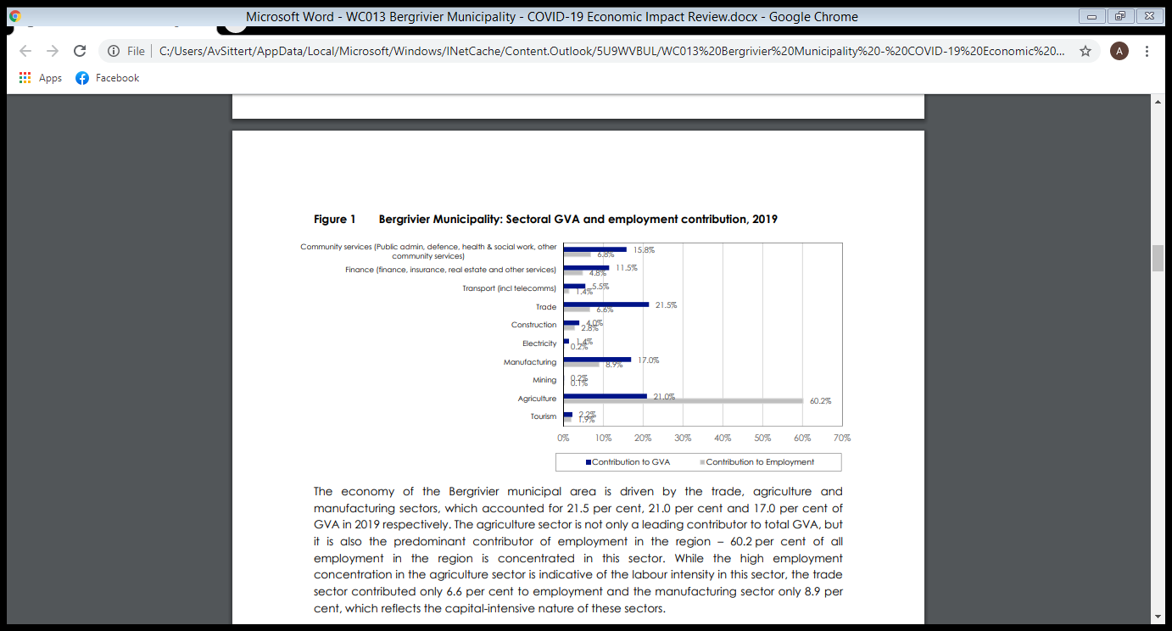The figure below illustrates the breakdown of the sector’s contribution to the GDPR and the employment base of the Bergrivier Municipal Area:

Sectors that are more labour intensive have a larger socio-economic impact when confronted with adverse economic conditions (such as the drought and Covid-19). Job losses in such sectors negatively impact on the income of the employees which has the knock-on effect of lower demand for goods and services produced across all sectors. The overall anticipated impact of the lockdown and consequent easing of restrictions on the economies of the Bergrivier municipal economy and employment is reflected in the following figure:

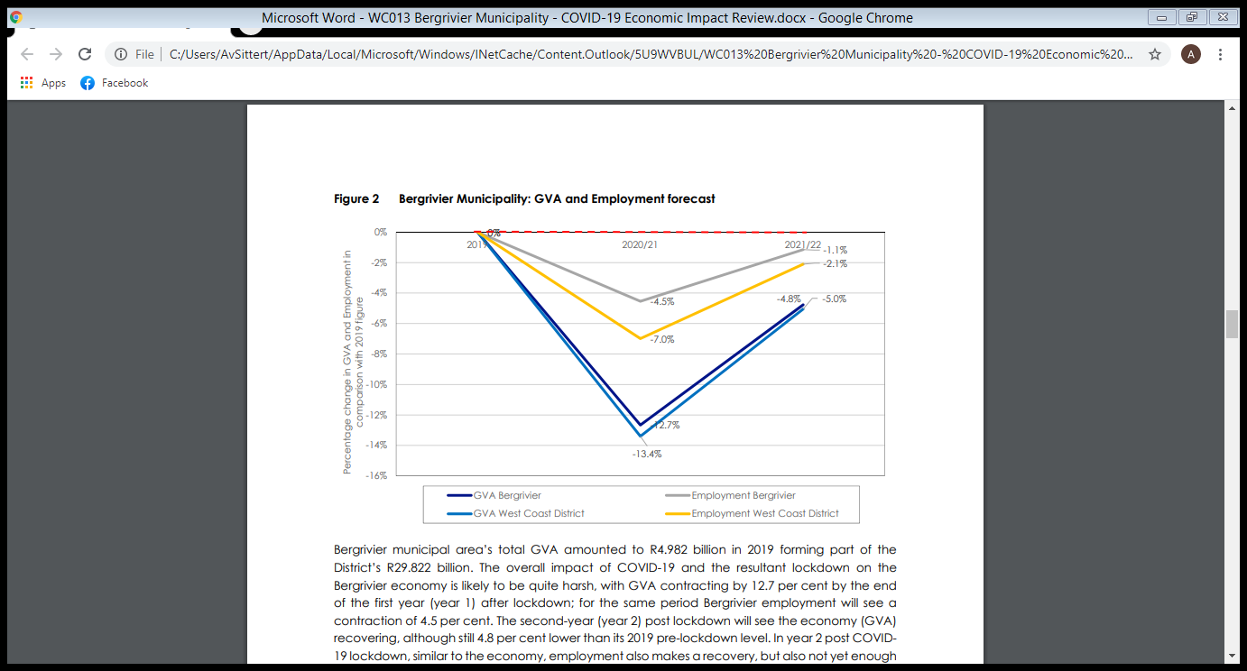**GVA and Employment Forecast**

The overall impact of Covid-19 and the resultant lockdown is likely to be harsh on the Bergrivier economy, with GVA contracting by 12.7 % by end of Year 1 after lockdown and 4.5 % contraction of employment. In Year 2 post-Covid-19 will make a recovery, but not enough to get to pre-lockdown employment levels.

The very essence of the impact of Covid-19 and the subsequent lockdown on the economy of Bergrivier Municipality can be summarized as follows:

|  |  |  |
| --- | --- | --- |
|  | **YEAR 1 POST C-19** | **YEAR 2 POST C-19** |
| **GVA** | **-12.7%** | **9.0%** |
| **Employment** | **-4.5%** | **3.6%** |

The following tables provides firstly an overview of the impact of the lockdown on the GVA of Bergrivier Municipal Area and secondly in terms of job losses per sector:

|  | | **TOTAL GVA IN 2019** | | **POST 1-2 MONTHS GVA LOSS** | **POST 3-6 MONTHS GVA LOSS** | **POST 7-12 MONTHS GVA LOSS** | **NET GVA LOSS** | **NET LOSS AS A % OF SUB SECTOR** | **NET LOSS AS A % OF TOTAL GVA** | **POST 13 - 24 MONTHS GVA LOSS** |
| --- | --- | --- | --- | --- | --- | --- | --- | --- | --- | --- |
| Tourism | 111,932 | | 13,534 | | 35,818 | 44,773 | 94,125 | 84.1% | 1.9% | 55,966 | |
| Agriculture | 1,043,840 | | 36,047 | | 34,795 | 11,444 | 82,286 | 7.9% | 1.7% | 10,512 | |
| Mining | 8,014 | | 792 | | 668 | 152 | 1,612 | 20.1% | 0.0% | 481 | |
| Manufacturing | 846,774 | | 37,696 | | 49,807 | 22,832 | 110,335 | 13.0% | 2.2% | 51,444 | |
| Electricity | 69,780 | | 949 | | 1,595 | 698 | 3,241 | 4.6% | 0.1% | 3,489 | |
| Construction | 198,274 | | 14,871 | | 26,351 | 39,494 | 80,715 | 40.7% | 1.6% | 19,827 | |
| Trade | 1,069,178 | | 51,257 | | 46,737 | 43,393 | 141,386 | 13.2% | 2.8% | 61,734 | |
| Transport (incl telecomms) | 273,522 | | 19,382 | | 10,227 | 12,135 | 41,744 | 15.3% | 0.8% | 6,267 | |
| Finance (finance, insurance, real estate and other services) | 572,021 | | 10,000 | | 9,534 | 11,663 | 31,196 | 5.5% | 0.6% | 23,689 | |
| Community services (Public admin, defense, health & social work, other community services) | 789,054 | | 8,949 | | 17,804 | 17,348 | 44,101 | 5.6% | 0.9% | 4,217 | |
|  | **4,982,387** | | **193,476** | | **233,335** | **203,931** | **630,742** |  |  | **237,626** | |
|  |  | | **3.88%** | | **4.68%** | **4.09%** | **12.66%** |  |  | **4.77%** | |

|  | **TOTAL EMPLOYED IN 2019** | **POST 1-2 MONTHS EMPLOY-MENT LOSS** | **POST 3-6 MONTHS EMPLOY-MENT LOSS** | **POST 7-12 MONTHS EMPLOY-MENT** | **NET EMPLOY-MENT LOSSES** | **NET EMPLOY-MENT LOSS % OF SUBSECTOR** | **NET LOSS AS A % OF TOTAL EMPLOY-MENT** | **POST 13 - 24 MONTHS EMPLOY-MENT LOSS** | **NET LOSS AS A % OF EMPLOY-MENT** |
| --- | --- | --- | --- | --- | --- | --- | --- | --- | --- |
| Informal | 1,763 | 91 | 99 | 35 | 224 | 12.7% | 0.8% | 14 | 0.8% |
| Tourism | 533 | 44 | 123 | 154 | 320 | 60.0% | 1.2% | 128 | 24.0% |
| Agriculture | 16,725 | 31 | 139 | 37 | 208 | 1.2% | 0.7% | 1 | 0.0% |
| Mining | 38 | 0 | 1 | 0 | 2 | 4.4% | 0.0% | 1 | 2.1% |
| Manufac-turing | 2,482 | 13 | 49 | 28 | 90 | 3.6% | 0.3% | 51 | 2.0% |
| Electricity | 44 | 0 | 0 | 0 | 1 | 1.3% | 0.0% | 1 | 1.8% |
| Construction | 779 | 44 | 58 | 99 | 202 | 25.9% | 0.7% | 37 | 4.8% |
| Trade | 1,831 | 12 | 29 | 42 | 83 | 4.5% | 0.3% | 47 | 2.6% |
| Transport (incl telecomms) | 385 | 3 | 7 | 12 | 21 | 5.5% | 0.1% | 6 | 1.6% |
| Finance (finance, insurance, real estate and other services) | 1,334 | 6 | 9 | 16 | 31 | 2.3% | 0.1% | 25 | 1.9% |
| Community services (Public admin, defense, health & social work, other community services) | 1,892 | 3 | 32 | 46 | 81 | 4.3% | 0.3% | 9 | 0.5% |
| Total | 27,805 | 248 | 546 | 469 | 1,263 |  |  | 320 |  |
|  |  | 0.89% | 1.96% | 1.69% | 4.54% | -4.5% |  | 1.15% |  |

Covid-19 pandemic is both a health crisis and a far-reaching global economic crisis. The short term impact on the Bergrivier local economy is likely to be harsh, with significant declines in both the GVA and employment and a lengthy recovery period. This is being aggravated by the general recessionary and high unemployment environment pre-Covid. The immediate priority will be to support economic activities as far as possible and to alleviate poverty through various economic and social interventions.

## 3.4 Bergrivier Municipality: Impact of Covid-19 on the socio-economic profile of Bergrivier Municipality

One of the most important aspects of the impact of Covid-19 is the impact on the socio-economic profile of the communities in Bergrivier Municipal Area. However this is complicated to quantify and qualify at such an early stage. Little verified data is available and a first attempt to analyse the impact is made, but needs further study and consultation with the relevant authorities. The Covid-19 pandemic created tremendous challenges for the most vulnerable groups and weakened social services.

Immediate analysis may include the more generic indicators such as the Gini Co-efficient or the Human Development Index or literacy statistics, but this may not quantify the impact that Covid-19 and the subsequent lockdown had on the socio-economic profile of communities. These indicators may only be relevant over a longer period.

For the purposes of this Economic Recovery Plan, a simple framework was developed and ad hoc comments and statistics are included in the provisional analysis. The following is relevant:

### 3.4.1 Impact of Covid-19 on food security

The immediate visible impact of Covid-19 and the subsequent lockdown was the need to provide food to the vulnerable. The vulnerable also included temporary workers such as domestic workers and gardeners. Velddrif has had a feeding scheme for a considerable period, whilst Eendekuil, Piketberg and Porterville commenced with feeding schemes.

The pressure on the feeding scheme in Velddrif increased exponentially. This is due to the increase in unemployment which had a direct impact on the finances of the feeding scheme. This was made worse as food had to be given over weekends as well whereas no food is normally served over weekends. The Porterville feeding scheme started registering each and every recipient of food on a daily basis and helped to identify the poorest of the poor households.

A feeding scheme commenced in Eendekuil under the auspices of a partnership of Initiative for Community Advancement, Cederberg Matzikamma AIDS Network and Die Liggaam van Christus church. A nutritional programme served meals to primarily children and the elderly on a daily basis. In April 2020 a total of 3 019 cooked meals were provided. The closure of the feeding schemes at schools had an immediate impact on children not having food on a regular basis.

Bergrivier Municipal Area is predominantly an agricultural area and a number of seasonal workers could work in May in the citrus industry. The Department of Basic Education also commenced with school feeding schemes on Tuesdays and Thursdays, but had no significant impact on the number of people being fed in these months.

A feeding scheme in Piketberg is being co-ordinated under the auspices of the Mayor and 350 people are being fed every Tuesday and Thursday. A similar feeding scheme will commence in Redelinghuys.

In Velddrif, Piketberg and Porterville a number of homeless shelters had to be established and food was provided on a regular basis to the homeless people.

Unemployed individuals and/or families living on farms also received food hampers on a regular basis. The criteria of the Department of Social Development to only provide hampers to people not receiving social grants, excluded a number of poor families due to the lockdown and exposed the lack of knowledge of poor families to budget their monthly grants.

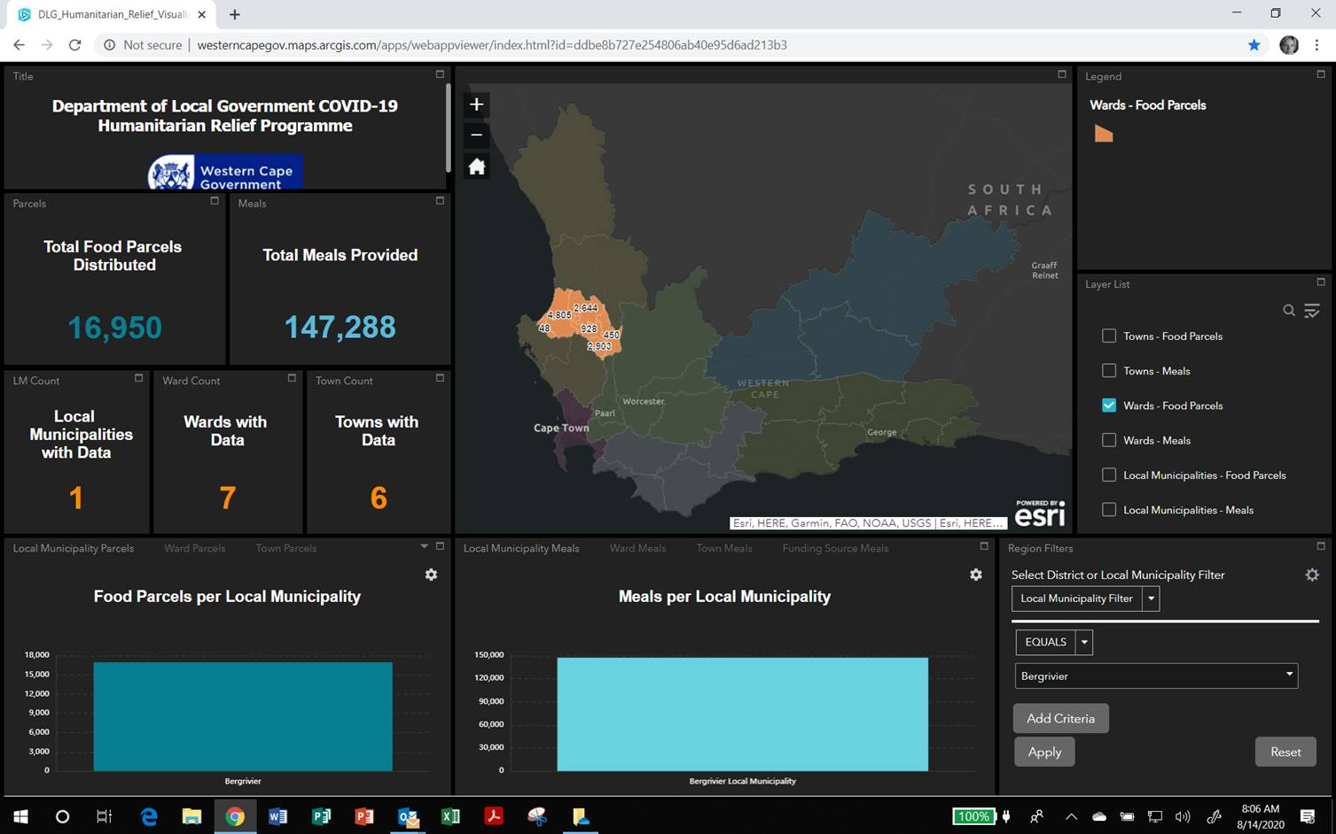Western Cape Provincial Government developed a database of humanitarian relief during the various levels of lockdown. The following image is the extent of humanitarian aid in Bergrivier Municipal Area until 6 Augustus 2020:

### 3.4.2 Impact of Covid-19 on children and the youth

Social distancing and human mobility restrictions disrupted households and exposed them to financial deficiencies and court permission to return children to the caregiver/parents. During the period 2 incidents were reported of children in need of court permission to return to their parents. Threats to the children’s safety and well being (including physical abuse, child neglect and sexual abuse) were not necessarily reported to the Department of Social Development and no real statistics are available on the frequency of such abuse to children. However, the risk of children not being in school, with poor literacy and access to internet could have affected motivation and behavioural challenges. The care and protection of the vulnerable were further limited due to professionals not being able to function full capacity due to the regulations.

Unemployment amongst the youth necessarily also increased. The closure of Technical and Vocational education and training centres hampered the developing and strengthening of skills development, job and income generation opportunities.

### 3.4.3 Impact of Covid-19 on the elderly

The elderly and especially homeless people were severely vulnerable. Social isolation increased and the elderly in residential facilities had none or limited contact with their families and loved ones. The request for care and protection services to abused elderly was significantly less than before the pandemic announcement.

### 3.4.4 Impact of Covid-19 on crime

Information provided relates to the period 2020-03-27 till 2020-08-17 compared to the same period in 2019 - thus 2019-03-27 to 2019-08-17. As crime statistics cannot be provided this report relates to crime tendencies during the mentioned period.

Bergrivier policing areas within the Vredenburg Cluster includes the following policing precincts: SAPS Piketberg, SAPS Porterville, SAPS Laaiplek, SAPS Redelinghuys and SAPS Eendekuil. The feedback is handled under the following headings:

* The impact Covid 19 had on general Crime in the Bergrivier area.
* The impact of Covid 19 on Substance abuse
* The impact of Covid 19 on Gender based Violence

***The impact of Covid 19 on Gender based Violence***

As the term Gender Based Violence is very wide and includes any violent action against both male and female based on gender issues, the report focusses specifically on reported incidents of Domestic Violence during the mentioned period in the Five (5) Bergrivier towns.

When comparing the statistics of incidents of Domestic Violence reported 2019-03-27 till 2019-08-17 to incidents reported 2020-03-27 till 2020-08-17 the following is noted:

* The towns of Porterville and Eendekuil showed a sharp increase of incidents of Domestic Violence reported.
* Laaiplek showed a marginal increase in reported cases of Domestic Violence, while Piketberg and Redelinghuys showed a decrease in reported cases.
* When comparing figures of all the Bergrivier stations the area showed an increase in reported cases of Domestic Violence.

Of concern is that only 3 Cases were reported to the Department of Social Development which is significantly less than the reporting of the DSD. DSD reported that human resource capacity was increased with the appointment of a VEP social workers in the service area.

***The impact of Covid 19 on Substance abuse***

Substance abuse includes both the abuse of legal and illegal substances ie. Drugs and Liquor. All towns in the Bergrivier area showed a decrease in the reported cases for Possession of Drugs as well as Offences relating to the abuse of Liquor. This could be ascribed to various factors which include i.e.estrict Covid-19 curfew implementation under lockdown Level 5, the lessened availability of these products and the increased focus on movement of persons.

***The impact Covid 19 had on general Crime in the Bergrivier area***

As General Crime is a very wide term, focus was placed on the priority crimes prevalent in this area. These crimes include Housebreakings, Assault and Theft.

**Housebreakings**:

Housebreakings in most of the areas showed a sharp decrease in the beginning of the lockdown period. It is noted however that as the lockdown levels have become less restrictive, the reported housebreaking cases have increased. It needs to be mentioned that the area is also affected by the release of offenders on Special Remission during this time.

**Assaults :**

Assaults in the Bergrivier area generally showed a decrease but as mentioned Domestic Violence related assaults/ incidents showed an increase.

**Thefts**:

In the areas of Piketberg and Porterville, reported theft cases showed a decrease in the earlier period of lockdown, yet as Housebreaking it increased during the latter part of lockdown. Reported cases in the Redelinghuys and Eendekuil area stabilised. In the Laaiplek area reported Theft cases showed an increase in the beginning of the Lockdown period and decreased to the latter period. Common Robbery cases reported very few cases during this period. The lack of reporting does, however, not mean that these incidents may not have occurred, only that people did not lay criminal cases.

## 3.5 The Joint District Approach in and for the West Coast

It is important to acknowledge the importance of the Joint District Approach also in the implementation of the Economic Recovery Plan for the municipalities and for the district.

The objectives of the District Development Model within Covid-19 include inter alia the following relevant to the economic recovery plan:

1. Foster a practical intergovernmental relations mechanism to plan, budget and implement jointly in order to provide a coherent government (solve silos, duplication and fragmentation); and
2. Co-ordinate a government response to Post Covid-19 challenges to poverty, unemployment and inequality, particularly amongst women, youth and people living with disabilities

Principles for guiding the Covid-19 District Development Model approach include inter alia in terms of the economic recovery plan:

1. DDM will play a central role of mobilizing state and civil society to respond strategically to Covid-19 with a new economic approach and plan; and
2. Use the opportunity that Covid-19 presents to address the two economies (formal and informal).

The focus areas and key generic elements of interventions to address the economic and social impact of Covid-19 in and for the West Coast District collectively and individually for the various municipalities include inter alia:

| CATEGORY | DETAIL |
| --- | --- |
| Mitigation of the impact of loss of household incomes, increased poverty and lack of access to services | Adequate provision of food parcels |
| Adequate access to Social Relief for Distress grants |
| Ensuring equitable access to education and online learning | Schools to be Covid-19 compliant |
| Learners to have access to online learning |
| Reducing vulnerability and prioritising the poor | Adequate provision of homeless shelters |
| Interventions for psycho-social support (hotlines, counselling) |
| Adequate provision for people with disability |
| Promoting awareness and access to Economic Relief Measures | Ensure employers/employees have access to UIF Relief Measures |
| Are small businesses aware of the Department of Small Business Development Relief Schemes |
| Do small businesses need assistance in applying for relief schemes? |
| Are small businesses aware and have access to the IDC Economic Relief Facility |
| Economic Recovery Readiness | What are the key industries that need assistance for recovery |
| Have key sectors with highest potential to grow the local economy been identified? |

The reality of the above study in practical terms include:

* 92 % of SMME business operations have been impacted by Covid-19;
* Over 55 000 SMME’s in SA will not survive the pandemic;
* The travel restrictions, the inability to interact with clients face to face and the cancellations of engagements have had the greatest impact on businesses;
* 71 % of SMME businesses do not have enough cash to keep their business operational in the next 3 months;
* The retail/trade, construction and general services sectors reflect that just 50 % of these businesses expect to generate no revenue in the next 3 – 6 months;
* Telecommuting and online learning will increase, thus disrupting offerings in many sectors;
* There will be an increased confidence in technology as an enabler to most of our daily activities, namely improved FinTech and EdTech solutions;
* Innovative Start-Ups will be on the rise as they seek to leverage the disruption created by the pandemic, such a no-contact deliveries, artificial intelligence and big data analytics;
* More businesses will opt for co-working spaces and virtual working;
* There will be a social change where the private and public sector will invest more in underserved communities by improving telecoms infrastructure, basic services and making hygiene practice part of our daily lives.

# 4. POTENTIAL SHORT-, MEDIUM AND LONG TERM INTERVENTIONS IN THE ECONOMIC RECOVERY FOR BERGRIVIER MUNICIPALITY

## 4.1 Points of Departure

The following points of departure are important in the identification of potential interventions for the economic recovery of Bergrivier Municipal Area:

1. All interventions must be realistic and implementable to have an impact;
2. Distinguish between short-, medium and long term interventions;
3. Support worst-affected sectors;
4. Be responsive to businesses in crisis through information, communication, guidance, support to access funding and advocacy;
5. Government does not have the fiscal space to effect the economic plan and it requires other stakeholders and resources from private sector to contribute;
6. A whole of government approach will be needed in the fight against Covid-19 and it is important for an integrated aligned approach that will include

* Health
* Social support
* Economy
* Water, Sanitation and Human Settlements
* Transport
* Resource Management, especially finance and human resources
* Safety and Security
* Communication

Eventually what needs to be achieved in the Bergrivier Municipal Area for all would be:

* High levels of employment;
* Low levels of inequality;
* Low levels of poverty;
* Low levels of debt and high savings;
* High life expectancy;
* Low levels of impact on the environment;
* Very little crime;
* High levels of social cohesion; and
* High standards of quality of life for everyone

## 4.2 Practical implementation plans for Bergrivier Municipal Area

### 4.2.1 Impact per sector

The sectors where GVA will be hit hardest by the lockdown restrictions is tourism (84.1 %), construction (40.7 %), mining (20.1 %) and transport and telecoms (15.3 %). The majority job losses will come from tourism (60 %), construction (25.9 %) and informal sectors (12.7 %). It is estimated that in the first 2 months of the lockdown, total GVA output will decline by 3,9 %, 3 – 6 months an additional 4.7 % decline and 7 – 12 months an additional 4.1 % decline. The total decline for the 12-month period will be 12.7 %. Months 13 – 24 post-lockdown will still be 4.8 % lower than its 2019 pre-lockdown level.

Within the first 2 months of lockdown, total employment declined by 1.6 %, months 3 – 6 an additional 3.2 % and months 7 – 12 a further decline of 3.4 % in employment. In month’s 13 – 24 post-lockdown, employment will still be 2.6 % lower than its 2019 level. The following is a brief discussion of the sectoral implications of Covid-19 and the subsequent lockdown:

#### 4.2.1.1 Financial and Business Sector

This sector will probably feel the effects either at a later stage or to a lesser degree than a number of the other sectors. Most of the daily operations in this sector could be done remotely and most of these were also termed as essential services. Although they may not be exempt from job losses, the sector will be able to bounce back quicker due to their very nature. The sector may be under strain due to the clientele not being able to service their debts and cancel their insurances. The pressure may also be on the homeowners being forced to sell their property and even landlords and property owners may be pressured to provide relief for tenants, including business tenants.

#### 4.2.1.2 Trade Sector

The trade sector (wholesale, retail, catering and accommodation) suffered significantly under the Covid-19 restrictions, with non-essential retailers having to close down. Losses in household income further reduces the demand for this sector’s goods and services. The impact of Covid-19 is expected to strip R 141 386 million off this sector and presents a 13.2 % contraction i.t.o GVA.

#### 4.2.1.3 Tourism Sector

The tourism industry that was the hardest hit in the Bergrivier Municipal Area is the tourism sector. Lower visitor numbers, both national and international, had a direct impact on the accommodation and restaurant industry and could be devastating if the lockdown on the tourism industry continues for much longer. Indications are that the typical tourist may only be willing to travel again from July 2021 or even later, meaning that the expected occupancy for the traditional high season may also be impacted upon. Travelling cost (especially flight tickets) may become more expensive. Even after lockdown, there will be restrictive measures to enforce social distancing and limit crowds. This could impact on restaurant capacity limitations. Tourism is likely to recover only 50 % of its 2019 GVA value within the 13 – 24 months period after lockdown and only 24 % of its 2019 employment figure.

Virtual meetings are currently being held with the tourism offices as to determine whether some businesses may close and the interventions required to ensure that Bergrivier tourism is ready after lockdown.

#### 4.2.1.4 Construction Sector

This sector has been hit hard by the lockdown and may take a considerable period to recover. However, parts of this industry have been regarded as essential services and could therefore operate during lockdown, and include especially repairs and maintenance and municipal programme. Discussions with DEDAT and Saldanha IDZ are currently being held to determine the potential opportunities for Velddrif businesses in the Saldanha IDZ.

#### 4.2.1.5 Agriculture and fisheries

Although the effects of Covid-19 may have had limited impact on the agriculture as it has been regarded as an essential service since lockdown, the longer term drought and water shortages already placed the industry under stress. Exports and transport of cargo (produce) may have been limited, and market access to other countries may have been affected, with examples of the wine industry and flower industry from the region as good examples. There were some unintended consequences for this sector it will be 1 % short in the 13- 24 months post-lockdown period than the 2019 figure i.t.o. GVA and employment will make a full recovery.

However, as agriculture has a specific programme, no specific reference in the Economic Recovery Plan will be made to this sector, except for reference to food security for indigent households.

#### 4.2.1.6 ICT and Smart Cities

This sector will remain resilient as it is both an essential service and an integral part of the development and growth of the region. However, with the limited band width and limited internet access for households as a basic service, the potential of this sector to stimulate the economy may be hampered. The enhancement of “smart” applications by municipalities and the private sector will see more remote work access and less travel. The experiences of Cape Agulhas municipality in implementing SMART city programmes should be investigated and potentially explored for Bergrivier Municipality.

#### 4.2.1.7 Waste management, energy and water

This sector experienced minimal impact from Covid-19, especially as South Africa is being regarded as a major opportunity for renewable energy projects and water supply issues. Active facilitation of creating an environment conducive to investment in this sector will be crucial, especially as it tends to be a competitive environment for municipalities.

#### 4.2.1.8 SMME and Informal Sector

Although this is not an industry per se, Covid-19 had a severe impact on the small business sector with considerable businesses closing and/or struggling to survive and/or retrenching staff. Specific attention will have to be given to this industry as it tends to be a safety net for a number of families not being able to obtain employment or as a means for survival.

Within Bergrivier, the informal sector provides employment to 9.9 % of the workforce. It is expected this sector will have a 12.7 % decline in employment within one year after lockdown. The impact of the losses on this largely financially vulnerable group may require some intervention to keep households afloat. Most of these jobs lost is likely to be recovered within the 13 – 24 months post lockdown (0.8 %) to the 2019 employment figures. The formalisation of the informal industry will also have to be receive dedicated attention as funding available for this sector requires the businesses to be compliant.

### 4.2.2 Implementation Plan

The following practical implementation plans for Bergrivier Municipal Area are proposed:

| SECTOR | CATEGORY | DETAIL | RESPONSIBLE |
| --- | --- | --- | --- |
| Tourism | Information dissemination | Guide tourism industry where to find assistance to apply for relief/stimulus packages ([www.supportbusiness.co.za](http://www.supportbusiness.co.za), [www.bizportal.gov.za](http://www.bizportal.gov.za) | Manager: BTO and Strategic Services |
| Guide and advice business ito the regulations and health protocol | Manager: BTO and Strategic Services |
| Interventions | Organise training session on the importance of ensuring that business is online | Manager: BTO |
| Video of Bergrivier Municipality with its service providers to be made | Manager: BTO |
| Special initiative to transform the industry: Commence with Porterville-case study in Piketberg to motivate SMME’s to enter the tourism industry | Manager: BTO and Strategic Services |
| Advocate the film readiness nature of Bergrivier Municipal Area | Manager: BTO |
| Tourism offices to list business opportunities in their respective towns for SMME’s to consider | Tourism offices |
| Facilitate the mosaic project in Porterville | Strategic Services |
| Construction | Information dissemination | Guide and advice business ito the regulations and health protocol | Strategic Services |
| Guide construction industry where to find assistance to apply for relief/stimulus packages ([www.supportbusiness.co.za](http://www.supportbusiness.co.za), [www.bizportal.gov.za](http://www.bizportal.gov.za), etc. | Strategic Services |
| Interventions | Organise training session on the importance of ensuring that business is online | Strategic Services |
| Discussions with Saldanha IDZ on including Velddrif in the supply chain of the investments in the IDZ | Strategic Services |
| Preferential procurement should be applied in sourcing construction companies with a preference to geographical local businesses | Supply Chain, Technical Services, Community Services |
| Small Business | Information dissemination | Guide small business sector where to find assistance to apply for relief/stimulus packages ([www.supportbusiness.co.za](http://www.supportbusiness.co.za), [www.bizportal.gov.za](http://www.bizportal.gov.za), etc. | Strategic Services |
| Webinars to be promoted | Strategic Services |
| Interventions | Establish a committee representative of each town and discuss weekly (virtual) the current situation and potential solutions | Strategic Services |
| Entrepreneurial skills development | SEDA and SEFA |
| Secure the services of key partners such as SEDA, NYDA & SEFA for access to funding and mentorship support programmes | Strategic Services |
| Support to SMME’s through online services, i.e. business registrations and templates as a service to business and start-ups |  |
| Informal Trade | Information dissemination | Guide small business sector where to find assistance to apply for relief/stimulus packages ([www.supportbusiness.co.za](http://www.supportbusiness.co.za), [www.bizportal.gov.za](http://www.bizportal.gov.za), etc. | Strategic Services |
| Guide and advice business ito the regulations and health protocol | Strategic Services |
| Formal sector | Invest in formalising the informal sector | SEDA |
| Stalls | Consider relief measures for tenants of stalls for a period | SEDA |
| Municipal Services | Rebates & other financial assistance | Ensure continuous registration of indigents | Financial Services |
| Preferential Procurement | Ensure that infrastructure projects and other material supply programmes benefit local businesses. | Technical Servcies, Supply chain |
| Job creation | Use infrastructure for job creation and business development | EPWP |
| Red tape | Minimisation of regulatory and red tape barriers – real and perceived | All |
| Infrastructure – Basic services | Ensure that the underserved communities have basic amenities such as water, electricity, sanitation – all aided by Smart Cities and IT for improved service | Technical Services |
| Water | Expand alien clearance programme to increase water supply | Technical Services |
| Energy | Drive IPP up-take in municipality of energy. Investigate in alternative energy solutions | Technical services |
| Waste management | Facilitate the application at SEDA for the Waste Ambassadors | Strategic services |
| EPWP | Maximise employment of semi- & unskilled workers through municipal programmes | All |
| Address identified socio-economic weakness area, such as single household mothers and unemployed youth |  |
| Manufac-turing |  | Diversify the economy through the Saldanha IDZ – details to be discussed | Strategic Services |
| ICT – Smart city develop-ment |  | Accelerate digital skills supply |  |
|  | Invite high potential niche-based tech companies to invest in Bergrivier |  |
|  | Speed up roll-out of fibre installations and increased connectivity |  |
| Social Relief | Feeding schemes | Ensure food security through feeding schemes | NGO’s |
| Food gardens | Ensure more food gardens to families to ensure their own food security | Strategic services |
| Safety and Security |  | Ensure the activation of all neighbourhood watches to ensure that crime is limited |  |
|  | Drive an anti-drug campaign to ensure that inhabitants don’t fall victim to drug abuse | Strategic Services |
| Investment |  | Market Bergrivier as an investment friendly area |  |
| Other government services | UIF | Assist applications for the UIF Temporary Employee Benefits |  |

## 4.3 Current funding options for businesses

There are a number of economic relief measures during Covid-19 which can assist in immediate relief, these measures are listed below and attached as Annexure B for more detail information:

* Debt relief finance scheme (Small Business Development Interventions)
* Restructuring of SEDA-Funded Loans (Small Business Development Interventions)
* Business growth/resilience facility (Small Business Development Interventions)
* Spaza Support Scheme (Small Business Development Interventions)
* COVID-19 Agricultural disaster support fund (Agriculture and Land Reform)
* Tourism relief fund (Tourism Sector Interventions)
* Tax measures (National Treasury)
* Loans (National Treasury)
* UIF Covid-19 relief benefit
* Social Relief Grant (SASSA)

**BERGRIVIER MUNICIPALITY – COVID -19 SURVEY**

**INDUSTRY SECTORS**

**Please indicate/complete by filling in the letter.**

|  |  |
| --- | --- |
| 1. **INDUSTRIAL MANUFACTURING**    1. Engines and parts    2. Servicing of engines and motors    3. Industrial equipment    4. Servicing and refurbishing    5. Fuel, lubricants and detergents |  |
| 1. **CONSTRUCTION ENGINEERING AND ARCHITECTURE**    1. Architecture and design    2. Construction    3. Building and construction products    4. Building and construction services    5. Engineering and related services    6. Electronic products and systems |  |
| 1. **MANUFACTURERS**    1. Chemical    2. Electrical appliances and equipment    3. Hand and machine tools    4. Plastic products    5. Automotive, aviation, marine and rail products    6. Furniture and fittings    7. Glass products    8. Cleaning equipment    9. Board, paper and stationery products    10. Packaging products    11. Safety and security products    12. Pool and garden products    13. Household appliances    14. Fabrics and textiles    15. Clothing and footwear    16. Household consumer products |  |
| 1. **CRAFTS AND HOME INDUSTRIES** |  |
| 1. **MINING AND BENEFICIATION**    1. Mining - metals and jewellery    2. Mining - other resources    3. Mining equipment and services    4. Jewellery manufacture    5. Jewellery retail |  |
| 1. **AGRICULTURE**    1. Dairy produce    2. Livestock farming and processing    3. Viticulture and wineries    4. Agricultural equipment    5. Agricultural services    6. General farming    7. Marine and aqua-culture    8. Agricultural products |  |
| 1. **FOOD PRODUCTS**     1. Wholesale food products    2. Retail food products    3. Beverage products    4. Snack products |  |
| 1. **HEALTHCARE**     1. Over the counter health products    2. Scheduled pharmaceuticals    3. Health and lifestyle services    4. Medical and hospital products    5. Medical and hospital services    6. Veterinary products and services |  |
| 1. **EDUCATION, DEVELOPMENT AND TRAINING**     1. Pre-primary, primary and secondary schools    2. Private colleges    3. Tertiary institutions    4. Educational services    5. Educational products    6. Educational projects    7. Other education organisations |  |
| 1. **COMMUNITY ORGANISATIONS AND PROJECTS** |  |
| 1. **REPRESENTATIVE ORGANISATIONS**     1. Trade unions    2. Professional bodies and associations    3. Industry associations |  |
| 1. **PROFESSIONAL SERVICES**    1. Training services    2. Management and consulting services    3. Personnel and related services    4. Legal and related services    5. Other services |  |
| 1. **GOVERNMENT**    1. National government body    2. Provincial government body    3. Local government body    4. Statutory body    5. Government project |  |
| 1. **FINANCIAL SERVICES**    1. Short term and life assurance    2. Accounting and auditing    3. Banking, securities and investments    4. Professional and financial services |  |
| 1. **INFORMATION TECHNOLOGY AND TELECOMMUNICATION**     1. IT hardware    2. IT software    3. General services    4. Internet and web products and services    5. IT solution products    6. Telecommunication services |  |
| 1. **WHOLESALE AND RETAIL TRADE**    1. National general retail chains    2. Specialist chains    3. Independent retailers    4. Restaurant chains and outlets    5. Distribution agents |  |
| 1. **PROPERTY AND REAL ESTATE**     1. Estate agents    2. Property and management services    3. Other |  |
| 1. **MEDIA MARKETING AND PUBLISHING**     1. Television media    2. Radio media    3. Newspapers    4. Magazines    5. Media services    6. Advertising, marketing, design and PR agencies    7. Out-of-home advertising    8. Events, conference and exhibition services    9. Specialised media programmes and projects    10. Book publishers |  |
| 1. **MEDIA PRODUCTION SERVICES**     1. Film, video and TV production    2. Production services    3. Reproduction and print    4. Signage    5. Promotional items    6. Printers and screen printers |  |
| 1. **SPORT**     1. Sports teams    2. Sports organisations    3. Sports products    4. Sports events    5. Sports other |  |
| 1. **CULTURE, ENTERTAINMENT, MUSIC AND RECREATION**     1. Performing bodies    2. Entertainment services    3. Recording companies    4. Events and productions |  |
| 1. **TRANSPORT AND LOGISTICS**     1. Freight, couriers and logistics    2. Other services |  |
| 1. **TOURISM, TRAVEL AND HOSPITALITY**    1. Air, road, sea and rail transport    2. Hotels and accommodation    3. Tour operators    4. Agents and organisations    5. Destinations and attractions |  |
| 1. **EXPORT AND TRADE**     1. Trading companies and agents |  |
| 1. **SERVICES**     1. Household services    2. Personal services    3. Office services |  |
| 1. **UTILITIES AND MUNICIPAL SERVICES** |  |
| 1. **INFORMAL SECTOR/S**    1. Hair salon    2. Barbershop    3. Spaza shop    4. House shops    5. Fruit & Vegetables (Stalls) |  |

|  |  |
| --- | --- |
| **BERGRIVIER MUNICIPALITY - COVID - 19 BUSINESS SURVEY** | |
| Question | Answer |
| **What industry does your business fall under ?** |  |
| **Complete Annexure "A"** |  |
|
|
| **Where are you located in the Bergrivier Municipal Area ?** | Answer |
| **Name the town** |  |
|
|
| **Are you a member of the Business Chamber or any other organised business structure?** | Answer |
| If yes, which Business Chamber and/or organized business structure |  |
|
|
| **Was your business open under the Level 5 and 4 lockdown restrictions ?** | Answer |
|  |  |
|
|
| **Is your business open under the Level 3 lockdown restrictions ?** | Answer |
|  |  |
|
|
| **When do you plan to reopen your business, if not open yet ?** | Answer |
|  |  |
|
|
| **How many full time employees does your business have ?** | Answer |
|  |  |
|
|
| **How many part time employees does your business have ?** | Answer |
|  |  |
|
|
| **On average, how many dependants does an individual staff member have ?** | Answer |
|  |  |
|
|
| **What is your percentage of your total salary to the total expenditure?** | Answer |
|  |  |
|
|
| **Are you forced to consider retrenchments ?** | Answer |
|  |  |
|
|
| **How many staff will you need to retrench?** | Answer |
|  |  |
|
|
| **With what percentage did you turnover decrease with lockdown?** | Answer |
|  |  |
|
|
| **How do you anticipate May & June 2020 turnover will change compared to 2019 ?** | Answer |
|  |  |
|
|
| **Will you be able to pay your monthly expenses for your business?** | Answer |
|  |  |
|
|
| **How has your landlord adjusted your rental ? You can comment where relevant?** | Answer |
|  |  |
|
|
| **Please indicate which travel bans impact your business** | Answer |
|  |  |
|
|
| **Does your business support small and medium business ? If so, please explain** | Answer |
|  |  |
|
|
| **Have you applied and qualified for any of fund relief options available through the government and various financial institutions ?** |  |
|  |  |
|
|
| **If yes to previous question, please tell us your experience with the application** | Answer |
|  |  |
|
|
| **If no to previous question, what kind of assistance do you need?** | Answer |
|  |  |
|
|
| **General comments on what could assist you to keep your business open** | Answer |
|  |  |
|
|
| **PLEASE EMAIL YOUR RESPONSE TO Davidsc@Bergmun.org.za or sbadmin@bergmun.org.za** | |
| **NOT LATER THAN 3 AUGUST 2020** | |